BANK LOAN REPORT QUERY DOCUMENT
- BANK LOAN REPORT | SUMMARY
KPI’s:
Total Loan Applications
SELECT COUNT(id) AS Total_Applications FROM Financial_loans

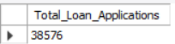
MTD Loan Applications
SELECT COUNT(id) AS MTD_Total_Applications FROM Financial_loans
WHERE MONTH(issue_date) = 12 and YEAR(issue_date) = 2021;
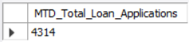
PMTD Loan Applications
SELECT COUNT(id) AS PMTD_Total_Applications FROM Financial_loans
WHERE MONTH(issue_date) = 11 and YEAR(issue_date) = 2021;
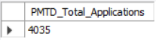

Total Funded Amount
SELECT SUM(loan_amount) AS Total_Funded_Amount FROM Financial_loans

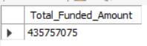
MTD Total Funded Amount
SELECT SUM(loan_amount) AS MTD_Total_Funded_Amount FROM Financial_loans
WHERE MONTH(issue_date) = 12 and YEAR(issue_date) = 2021;

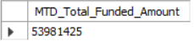
PMTD Total Funded Amount
SELECT SUM(loan_amount) AS PMTD_Total_Funded_Amount FROM Financial_loans
WHERE MONTH(issue_date) = 11 and YEAR(issue_date) = 2021;
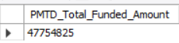

Total Amount Received
SELECT SUM(total_payment) AS Total_Amount_Received FROM Financial_loans

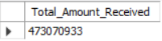
MTD Total Amount Received
SELECT SUM(total_payment) AS MTD_Total_Amount_ Received FROM Financial_loans
WHERE MONTH(issue_date) = 12 and YEAR(issue_date) = 2021;
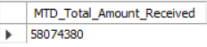
PMTD Total Amount Received
SELECT SUM(total_payment) AS PMTD_Total_Amount_Received FROM Financial_loans
WHERE MONTH(issue_date) = 11 and YEAR(issue_date) = 2021;
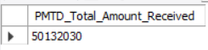

Average Interest Rate
SELECT ROUND(AVG(int_rate)*100,2) AS Avg_Int_Rate FROM Financial_loans

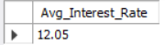
MTD Average Interest
SELECT Round(AVG(int_rate)*100,2) AS MTD_Avg_Int_Rate FROM Financial_loans
WHERE MONTH(issue_date) = 12 and YEAR(issue_date) = 2021;
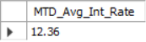
PMTD Average Interest
SELECT Round(AVG(int_rate)*100,2) AS PMTD_Avg_Int_Rate FROM Financial_loans
WHERE MONTH(issue_date) = 11 and YEAR(issue_date) = 2021;
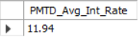

Avg DTI
SELECT Round(AVG(dti)*100,2) AS Avg_DTI FROM Financial_loans;
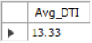
MTD Avg DTI
SELECT Round(AVG(dti)*100,2) AS MTD_Avg_DTI FROM Financial_loans
WHERE MONTH(issue_date) = 12 and YEAR(issue_date) = 2021;
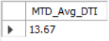
PMTD Avg DTI
SELECT Round(AVG(dti)*100,2) AS PMTD_Avg_DTI FROM Financial_loans
WHERE MONTH(issue_date) = 11 and YEAR(issue_date) = 2021;
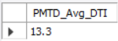

GOOD LOAN ISSUED
Good Loan Percentage
SELECT
(COUNT(CASE
WHEN loan_status = 'Fully Paid'
OR loan_status = 'Current'
THEN id
END) * 100.0)
/ COUNT(id) AS Good_Loan_Percentage
FROM financial_loans;
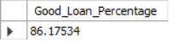
Good Loan Applications
SELECT
COUNT(CASE
WHEN loan_status IN ('Fully Paid', 'Current')
THEN id
END) AS Good_Loan_Applications
FROM financial_loans;
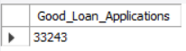

Good Loan Funded Amount
SELECT
SUM (CASE
WHEN loan_status IN ('Fully Paid', 'Current')
THEN loan_amount
END) AS Good_Loan_Funded_Amount
FROM financial_loans;
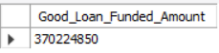

Good Loan Amount Received
SELECT
SUM (CASE
WHEN loan_status IN ('Fully Paid', 'Current')
THEN total_payment
END) AS Good_Loan_Received_Amount
FROM financial_loans;
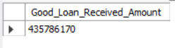

BAD LOAN ISSUED
Bad Loan Percentage
SELECT
(COUNT(CASE
WHEN loan_status = 'Charged Off'
THEN id
END) * 100.0)
/ COUNT(id) AS Bad_Loan_Percentage
FROM financial_loans;
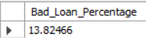
Bad Loan Applications
SELECT
COUNT(CASE
WHEN loan_status IN ('Charged Off')
THEN id
END) AS Bad_Loan_Applications
FROM financial_loans;

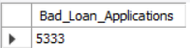
Bad Loan Funded Amount
SELECT
SUM (CASE
WHEN loan_status IN ('Charged Off')
THEN loan_amount
END) AS Bad_Loan_Funded_Amount
FROM financial_loans;
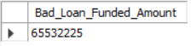

Bad Loan Amount Received
SELECT
SUM (CASE
WHEN loan_status IN ('Charged Off')
THEN total_amunt
END) AS Bad_Loan_Amount_Received
FROM financial_loans;
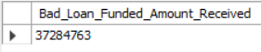

LOAN STATUS
SELECT
loan_status,
COUNT(id) AS LoanCount,
SUM(total_payment) AS Total_Amount_Received,
SUM(loan_amount) AS Total_Funded_Amount,
AVG(int_rate * 100) AS Interest_Rate,
AVG(dti * 100) AS DTI
FROM financial_loans
GROUP BY loan_status;

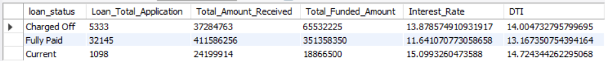

SELECT
loan_status,
SUM(total_payment) AS MTD_Total_Amount_Received,
SUM(loan_amount) AS MTD_Total_Funded_Amount
FROM financial_loans
WHERE MONTH(issue_date) = 12
GROUP BY loan_status;
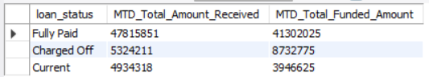

- BANK LOAN REPORT | OVERVIEW
MONTH
SELECT
MONTH(issue_date) AS Month_Number,
COUNT(id) AS Total_Loan_Applications,
SUM(loan_amount) AS Total_Funded_Amount,
SUM(total_payment) AS Total_Amount_Received
FROM financial_loans
GROUP BY MONTH(issue_date)
ORDER BY MONTH(issue_date);…………..
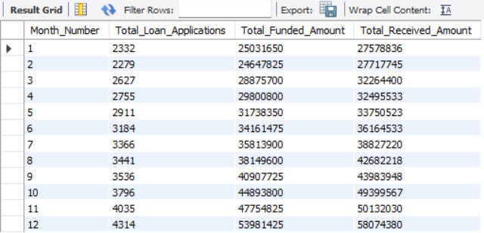

STATE
SELECT
address_state AS State,
COUNT(id) AS Total_Loan_Applications,
SUM(loan_amount) AS Total_Funded_Amount,
SUM(total_payment) AS Total_Amount_Received
FROM financial_loans
GROUP BY address_state
ORDER BY sum(loan_amount) desc;
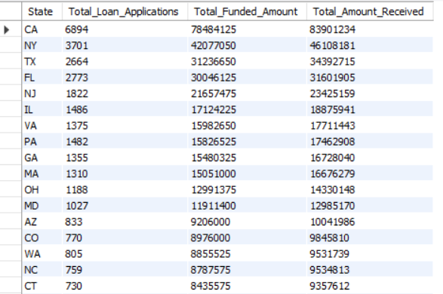

TERM
SELECT
term AS Term,
COUNT(id) AS Total_Loan_Applications,
SUM(loan_amount) AS Total_Funded_Amount,
SUM(total_payment) AS Total_Amount_Received
FROM financial_loans
GROUP BY term
ORDER BY term;
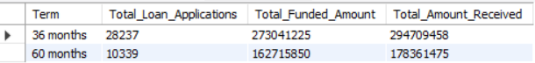

EMPLOYEE LENGTH
SELECT
emp_length AS Employee_Length,
COUNT(id) AS Total_Loan_Applications,
SUM(loan_amount) AS Total_Funded_Amount,
SUM(total_payment) AS Total_Amount_Received
FROM financial_loans
GROUP BY emp_length
ORDER BY emp_length;
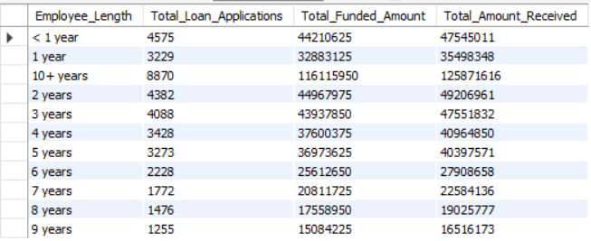
PURPOSE
SELECT
purpose AS PURPOSE,
COUNT(id) AS Total_Loan_Applications,
SUM(loan_amount) AS Total_Funded_Amount,
SUM(total_payment) AS Total_Amount_Received
FROM financial_loans
GROUP BY purpose
ORDER BY purpose;
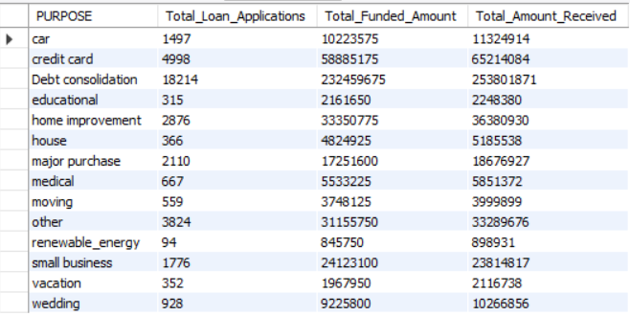

HOME OWNERSHIP
SELECT
home_ownership AS Home_Ownership,
COUNT(id) AS Total_Loan_Applications,
SUM(loan_amount) AS Total_Funded_Amount,
SUM(total_payment) AS Total_Amount_Received
FROM financial_loans
GROUP BY home_ownership
ORDER BY home_ownership;
